Electronic Regulatory Binder

Installation and Operation

Contents

Document Description 1

Requirements 1

Project Setup 2

Plugins Setup 2

REDCap CORE Modifications (Optional) 2

# Document Description

The Electronic Regulatory Binder (eReg binder) is a project within REDCap (http://project-redcap.org/) that was developed by Partners Human Research Quality Improvement (QI) Program and Enterprise Research Infrastructure & Services (ERIS). The eReg binder assists sites with the electronic storage and maintenance of regulatory documents for IRB approved protocols.

The project consists of

* A REDCap project (created as a template) (see Data Dictionary folder)
* A Protocol Version/Amendment Tracking Log plugin (va_tracking.php)
* Consent Form tracking plugin – (eb_consent_report.php)
* Delegation Log plugin – (create_eb_report.php)

# Requirements

In order to setup this project within your environment, you need to make sure that:

* You run PHP 5.3.3 or newer
* You run REDCap 5.9.14 and newer (tested in REDCap 5.9.14, 5.9.18, and 6.5.9)
* Have the appropriate redcap_connect.php (see REDCap Consortium website for details)
* common_functoins.php (part of this project)
* jquery.tablesorter.min.js (part of this project)
* (optional) If you want to provide this project as a template within your environment, you will have to make a modification to the REDCap core code. This modification will allow you to preserve the project bookmarks and custom project text when creating a new project from an existing template (see REDCap CORE modifications section)
* Final eReg Binder Manual – (part of the project) Link is included in the custom project description text

The plugins were designed and tested in on a LAMP stack environment, but the requirements should be the same for Windows-based systems.

# Project Setup

Create a new project in REDCap.

Upload the provided data dictionary file (ElectronicRegulatoryBinder_DataDictionary.csv) in Project Setup -> Data Dictionary

# Plugins Setup

The REDCap plugins are typically located within the “plugins” folder of the REDCap installations. In Linux, this is typically /var/www/html/redcap/plugins.

Within that folder, create a sub-folder called “eregbinder” (you can change this name to anything you wish).

Place the common_functions.php, create_eb_report.php, eb_consent_report.php, jquery.tablesorter.min.js, va_tracking_log.php files in that folder. Set the permissions as necessary for your installations.

In order to improve the security of the plugin, you can specify the project IDs that can access the plugin.

The plugins require that you include the Project ID (pid) parameter in the requests sent to the plugin. In order to do that, you need to check the box “Append Project ID to URL” when setting up the project bookmark (under Project Setup -> Add or Edit Bookmarks). Leave “Open in New Window” and “Append Record ID to URL” unchecked.

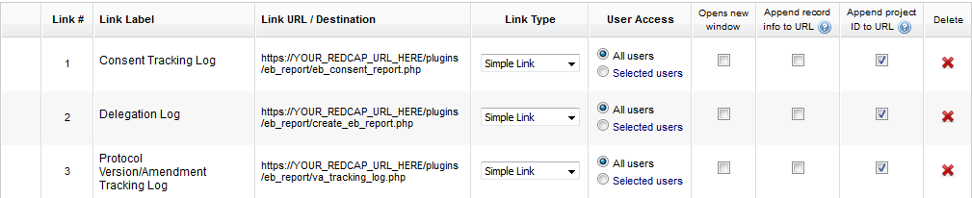

# REDCap CORE Modifications (Optional)

Currently REDCap does not have the ability to copy/create the project bookmarks from a template (i.e. when creating a project from a template, the bookmarks that may exist in that template project will not be copied over to the newly created project). In that case you will have to manually re-create the bookmarks described above for each project that wishes to use the eRegulatory Binder project template.

If you have a sufficient amount of projects that are going to request this template, it may be beneficial to modify the REDCap core code as follows:

(NOTE: The line numbers referenced below are from REDCap version 6.9.12 and may change with newer/older distributions.)

In ProjectGeneral/create_project.php at line 332

[…]

       ### START ADD EXTERNAL LINKS ###

       ## COPY THE PROJECT BOOKMARKS / EXTERNAL LINKS

        if ($isTemplate || (isset($_POST['copy_external_links']) && $_POST['copy_external_links'] == "on"))

        {

                $sql = "insert into redcap_external_links (project_id, link_order, link_url, link_label, open_new_window, link_type,

                                user_access, append_record_info, append_pid, link_to_project_id)

                                select '$new_project_id', link_order, link_url, link_label, open_new_window, link_type,

                                user_access, append_record_info, append_pid, link_to_project_id

                                from redcap_external_links

                                where project_id = $copyof_project_id";

                db_query($sql);

        }

     ### END ADD EXTERNAL LINKS ####

# COPY DATA QUALITY RULES (if a template OR if desired for copy)

if ($isTemplate || (isset($_POST['copy_dq_rules']) && $_POST['copy_dq_rules'] == "on"))

{

[…]

Then add "custom_index_page_note" at the end of the SQL statement on line 171 (through 178).

// Copy some defined project-level values from the project being copied

$projectFieldsCopy = array( "repeatforms", "scheduling", "randomization", "surveys_enabled", "field_comment_edit_delete",

"display_today_now_button", "auto_inc_set", "require_change_reason", "secondary_pk",

"history_widget_enabled", "order_id_by", "custom_record_label", "enable_participant_identifiers",

"survey_email_participant_field", "data_resolution_enabled", "project_language", "project_encoding",

"display_project_logo_institution", "survey_auth_enabled", "survey_auth_field1", "survey_auth_event_id1",

"survey_auth_field2", "survey_auth_event_id2", "survey_auth_field3", "survey_auth_event_id3",

"survey_auth_min_fields", "survey_auth_apply_all_surveys", "survey_auth_custom_message",

"survey_auth_fail_limit", "survey_auth_fail_window", "custom_index_page_note");

In ProjectGeneral/copy_project_form.php – at line 112 add

<br><input type='checkbox' name='copy_external_links' id='copy_external_links'> {$lang['eris_copy_external_links']}

This is the option to select that you want to copy the bookmarks when you are copying a project.

Within LanguageUpdater/English.ini add

eris_copy_external_links = "Add Bookmarks"

**NOTE:** The request to add this functionality to the core REDCap code was submitted to Vanderbilt and under review. It may be added to future REDCap versions.